Client(main function) will call for service layer and service will try to find the values in Repository layer.

To create a JDBC connection, you need to use JdbcTemplate class inside your repository file. 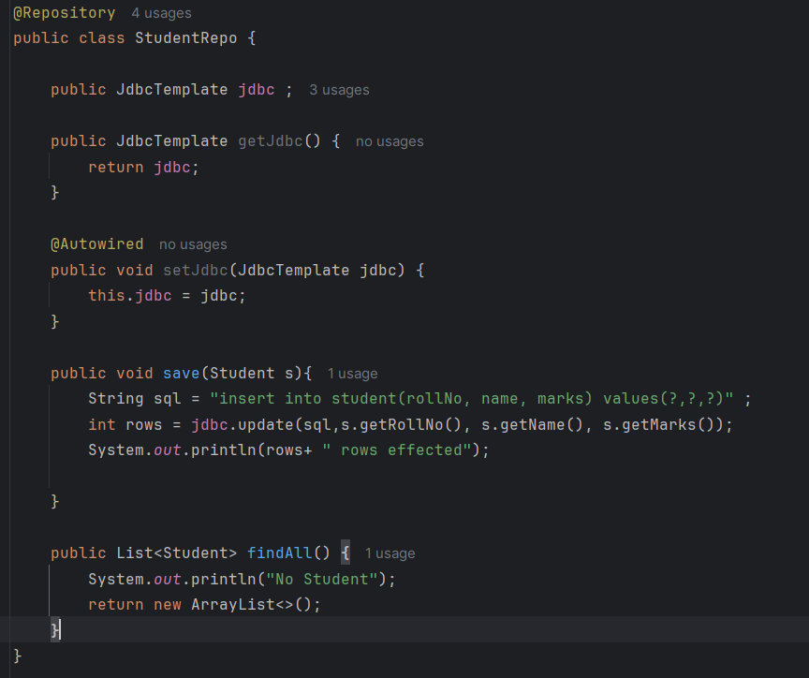
Now, as H2 is a In-Meomry DB, you need to have schema.sql(table defination), data.sql(values of that table) under resoureces. So, every time the program runs, a table will get created. [i.e. : Unlike H2 (which wipes your data every time the application stops), Oracle SQL is persistent. Once you create a table and insert data into it, it stays there forever.]
schema.sql: 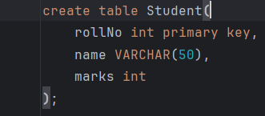
data.sql: 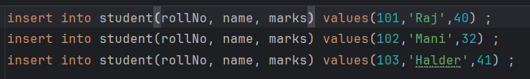

Service layer: 